TAF is the Terminal Aerodrome Forecast. Issued every 3 or 6 hours, valid for roughly 9 to 30 hours. In Ogimet it is represented with FC is a short TAF (valid under 12 hours) and FT is a long TAF (12 hours or more)
It is read as:-
050500Z: issued on the 5th at 05:00 UTC
- 0506/0612: valid from the 5th 06:00 to the 6th 12:00 (30 hours)
- 15006KT 3000 HZ FU NSC: starting conditions: wind 150° at 6 kt, visibility 3000 m, haze and smoke, no significant cloud
- BECMG 0509/0511 between 09:00 and 11:00 on the 5th, the wind becomes 290° at 10 kt and visibility is 4000 m. Cloud isn’t mentioned, so it stays NSC.
Example:
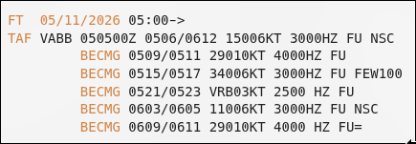
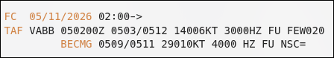
METAR is the Meteorological Aerodrome Report. In Ogimet it is represented with SA and SP is used to represent SPECI. Issued every 30 minutes, plus a SPECI report whenever conditions change significantly between scheduled reports.
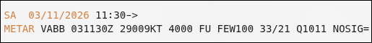
031130Z: the 3th, 11:30 UTC
- 29009KT: wind from 290° at 9 kt
- 4000: visibility 4000 m
- FU: smoke
- FEW100:few cloud at 10000 feet
- 33/21: temperature 33 °C, dew point 21 °C
- Q1011: pressure 1011 hPa
- NOSIG: no significant change expected in the next 2 hours

Steps for Verification:--
STEP 1)
METAR data is stretched for the next 30 minutes and is used for verification. Verification is done minutes by minutes.A SPECI cuts the previous METAR short, and each SPECI lasts until the next report.
STEP 2)
- Wind Direction is not checked if both forecast and observed wind speed are less than or equal to 6 kt. If there is variable wind or speed greater than 6 kt then wind direction is correct if it is within +60 or - 60.
- Wind Speed is correct if forecast and observed are within 10 kt.
- Visibility is correct if forecast height is less than or equal to 800 m then range is (-200 to +200). If height is greater than 800 then +30% to - 30%.
- Temperature is an exception that is measured only once, that is if both maximum and minimum are within range of (-1°C to +1°C). One of them gives half the credit.
- Precipitation is Yes or No only. Check if the forecast has thunderstorms, moderate or heavy rain, freezing rain etc.
- Cloud amount below 1500 then one category for SKC,FEW,SCT,BKN,OVC. Else class 1 for SKC,FEW,SCT and class 2 for BKN,OVC.
- Cloud Height only for BKN or OVC if less than or equal to 1000ft then range (-100 to 100) else for range 1000 to 5000 then range is (-30% to 30%).
STEP 3
- BECMG(Becoming) → After the change window ends then the new condition is applied fully. During its window it is treated like tempo.
- TEMPO(Temporary) → Short fluctuation, if correct then credit up to ½ of period and if not found then penalty of ⅓ of period.
- FM(From) → new conditions apply immediately from this time.
STEP 4
ICAO has a criteria for 80% for wind, visibility and precipitation. And 70% for cloud and temperature. Accuracy per element = accurate minutes ÷ verified minutes × 100. The overall score is the average weighted by verified minutes, and daily or monthly scores are weighted the same way. For example, 1,500 ÷ 1,800 = 83.33%.

